Lab 04

Systemy Wbudowane

Yan Ramanouski

Zadanie 1-2:

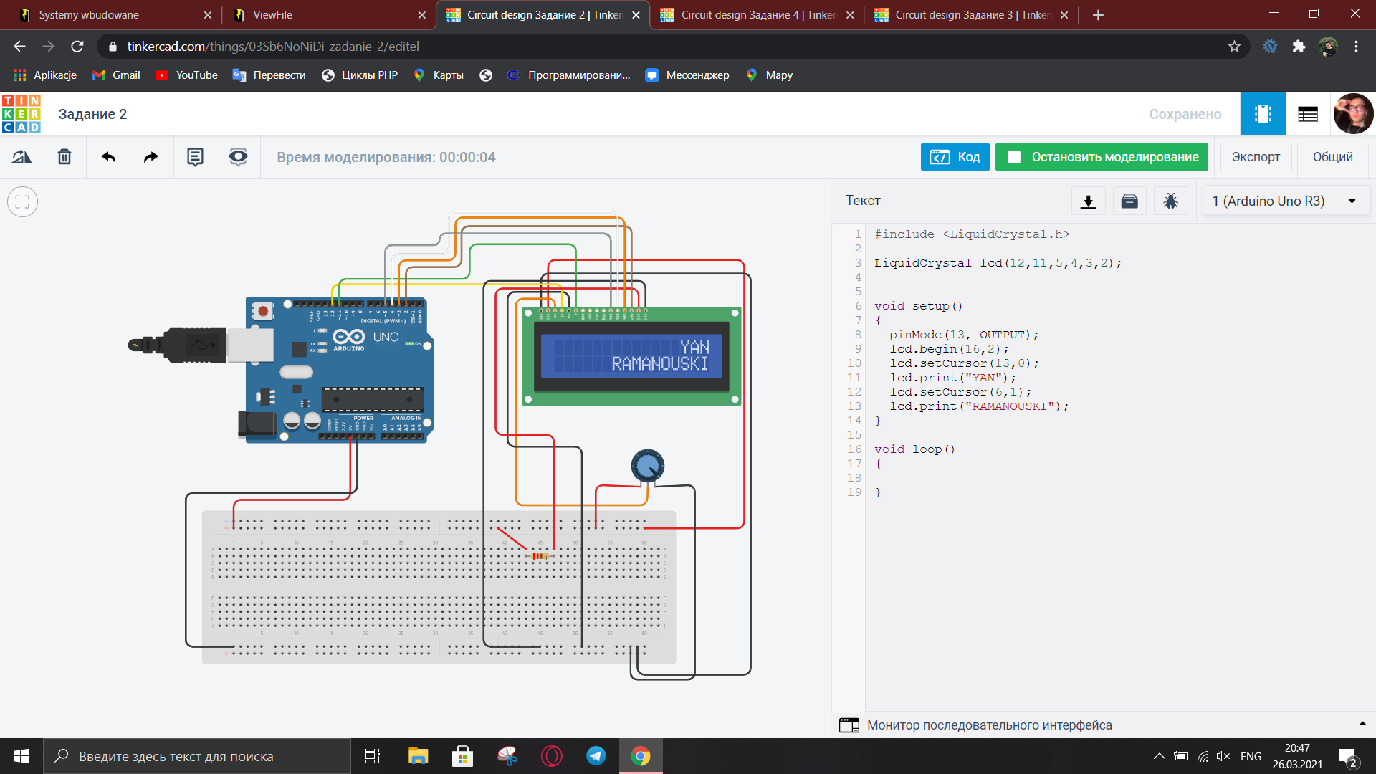

Code:

#include <LiquidCrystal.h>

LiquidCrystal lcd(12,11,5,4,3,2);

void setup()

{

pinMode(13, OUTPUT);

lcd.begin(16,2);

lcd.setCursor(13,0);

lcd.print("YAN");

lcd.setCursor(6,1);

lcd.print("RAMANOUSKI");

}

void loop()

{

}

Zadanie 3:

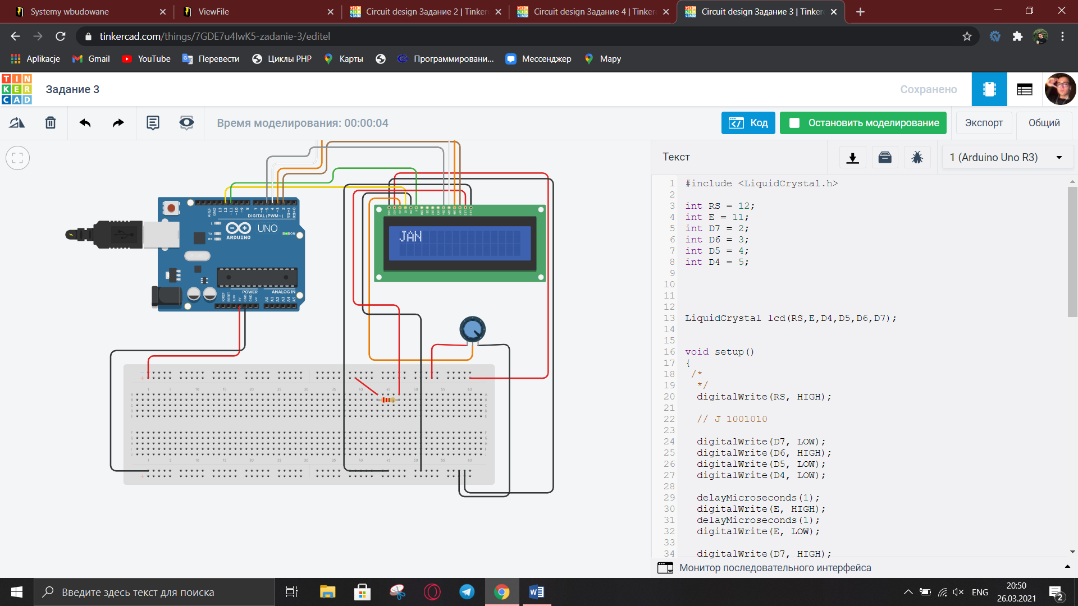

Code:

#include <LiquidCrystal.h>

int RS = 12;

int E = 11;

int D7 = 2;

int D6 = 3;

int D5 = 4;

int D4 = 5;

LiquidCrystal lcd(RS,E,D4,D5,D6,D7);

void setup()

{

/\*

\*/

digitalWrite(RS, HIGH);

// J 1001010

digitalWrite(D7, LOW);

digitalWrite(D6, HIGH);

digitalWrite(D5, LOW);

digitalWrite(D4, LOW);

delayMicroseconds(1);

digitalWrite(E, HIGH);

delayMicroseconds(1);

digitalWrite(E, LOW);

digitalWrite(D7, HIGH);

digitalWrite(D6, LOW);

digitalWrite(D5, HIGH);

digitalWrite(D4, LOW);

delayMicroseconds(1);

digitalWrite(E, HIGH);

delayMicroseconds(1);

digitalWrite(E, LOW);

// A 1000 001

digitalWrite(D7, LOW);

digitalWrite(D6, HIGH);

digitalWrite(D5, LOW);

digitalWrite(D4, LOW);

delayMicroseconds(1);

digitalWrite(E, HIGH);

delayMicroseconds(1);

digitalWrite(E, LOW);

digitalWrite(D7, LOW);

digitalWrite(D6, LOW);

digitalWrite(D5, LOW);

digitalWrite(D4, HIGH);

delayMicroseconds(1);

digitalWrite(E, HIGH);

delayMicroseconds(1);

digitalWrite(E, LOW);

// N 1001110

digitalWrite(D7, LOW);

digitalWrite(D6, HIGH);

digitalWrite(D5, LOW);

digitalWrite(D4, LOW);

delayMicroseconds(1);

digitalWrite(E, HIGH);

delayMicroseconds(1);

digitalWrite(E, LOW);

digitalWrite(D7, HIGH);

digitalWrite(D6, HIGH);

digitalWrite(D5, HIGH);

digitalWrite(D4, LOW);

delayMicroseconds(1);

digitalWrite(E, HIGH);

delayMicroseconds(1);

digitalWrite(E, LOW);

delayMicroseconds(39);

}

void loop()

{

}